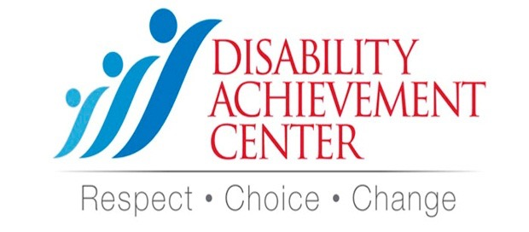

Would you be interested in participating in any of the following?

❑ Volunteering at the Center

❑ Attending events representing Disability Achievement Center

❑ Speaking at events (promoting Disability Awareness)

❑ Participating in county wide coalition

Let’s Stay Connected!!

12552 Belcher Rd. S.

Largo, FL 33773

Telephone: (727) 539-7550

Fax: (727) 539-7588

**www.DisabilityAchievementCenter.org**

Would you be interested in participating in any of the following?

❑ Volunteering at the Center

❑ Attending events representing Disability Achievement Center

❑ Speaking at events (promoting Disability Awareness)

❑ Participating in county wide coalition

Let’s Stay Connected!!

12552 Belcher Rd. S.

Largo, FL 33773

Telephone: (727) 539-7550

Fax: (727) 539-7588

**www.DisabilityAchievementCenter.org**

@DACOutreach

Make **change** happen,

Volunteer!

Make **change** happen,

Volunteer!

Just return this form and someone from the center will contact you with more information!

Name:_________________________________

Phone #:_______________________________

Email:__________________________________

Just return this form and someone from the center will contact you with more information!

Name:_________________________________

Phone #:_______________________________

Email:__________________________________